# Lexical

|  |
| --- |
| /ˈstɛlə/ stellar  1.[ADJ](javascript:;)Stellar is used to describe anything connected with stars. 星的; 星球的  •  A stellar wind streams outward from the star.  从那颗恒星上不断吹出恒星风。  2. [ADJ](javascript:;)A stellar person or thing = **extremely good 非常出色的，优秀的**  •the company’s **stellar growth** 这家公司辉煌的发展  •McKellen gave a **stellar performance** . 麦克凯伦的表演极为杰出优秀的  •  The French companies are registering **stellar profits.**   法国各家公司都获利丰厚。  e.g. All that added up to a stellar quarter for Pepsi ([PEP](http://money.cnn.com/quote/quote.html?symb=PEP&source=story_quote_link)), which reported sales and profits that topped Wall Street's forecasts. The stock rose nearly 1% on the news.  3. **[〔流行乐队、演员等〕走红. 出名, 变得极受欢迎: go stellar ]** informal if a pop band, actor etc goes stellar, they become very popular and famous.  e.g. There’s **a stand-up comedian单口喜剧演员**, and my sources tell me he is about to **go stellar.** 有个单口喜剧演员，据我所知他很快就要**走红/出名**了  e.g. That disgusting guy **went stellar** by his high-profile **hype-up炒作**。 |
| [ sth is decommissoned ]  1.使(军舰、军用飞机等)退役：to decommission an old airplane使一架旧飞机退役  2.关闭，停止使用(核反应堆、工厂等)，把(原子炉)作成废炉，废弃：to decommission a nuclear power plant 关闭一间核动力工厂  3.解除(军官)的军职： to decommission an officer解除一名军官的军职  decommission /ˌdiːkəˈmɪʃən/  [V-T](javascript:;)When something such as a nuclear reactor or a large machine is decommissioned, it is taken out of use and taken apart because it is no longer going to be used. 停止使用  •  The ships were to be decommissioned.   这些船即将被停止使用。  1.  The old ESS storage could now be decommissioned and removed from the data centre.  旧的 ESS 存储现在应该可以退役并从数据中心删除。  www.ibm.com  2.  Like any software, they need to be planned, designed, implemented, deployed, maintained, andultimately, decommissioned.  与任何软件类似，它们需要被规划、设计、实现、部署、维护和最终退役。  www.infoq.com  3.  This will aid their work when introducing new versions, by letting them communicate to relevantconsumers that they’re using a deprecated or decommissioned service and need to upgrade.  因此他们能够告知相关消费者正在使用过时或退役的服务，需要进行升级，这将简化服务目录管理员引入新版本的工作 |
| ['pɒmpəs] pompus: someone who is pompous thinks that they are important, and shows this by being very formal and using long words – used to show disapproval 自命不凡的，自高自大的；浮华的，虚夸的〔含贬义〕  E.g. I can’t stand those pompous people who try to show off how much they know about literature, but actually, they just know quiet little about it. |
| ['ɡrɪpɪŋ] **[ a gripping novel; a griping movie; a gripping story; 一部扣人心弦的惊险片: a gripping thriller]**  a gripping film, story etc is very exciting and interesting 〔电影、故事等〕扣人心弦的，引人入胜  e.g. JK Rollin’s **gripping** **crime thriller** get me totally lost in. I’m getting **so** pulled in **that** I cann’t put the book down until it’s finished. 扣人心弦的 // A thriller is a book, movie, or play that tells an exciting fictional story about something such as criminal activities or spying. 惊悚小说; 惊悚电影; 惊悚戏剧  e.g. Historical fiction, if it's well-written, can be absolutely gripping   /ɡrɪp/ grip sth      1.[V-T](javascript:;)If you grip something, you take hold of it with your hand and continue to hold it firmly. 紧握  •  She gripped the rope.  她紧紧抓住绳子。  2. [N-COUNT](javascript:;)A grip is a firm, strong hold on something. 紧握  •  His strong hand eased the bag from her grip.   他强有力的手使她把紧握的包松开。  3. [N-SING](javascript:;)Someone's grip on something is the power and control they have over it. 掌控  •  The president maintains an iron grip on his country.   总统保持着对国家的铁腕统治。  4. [V-T](javascript:;)If something grips you, it affects you very strongly. 强烈地影响  •  The entire community has been gripped by fear.   整个社区已被恐惧笼罩着。  5.  [V-T](javascript:;)If you are gripped by something such as a story or a series of events, your attention is concentrated on it and held by it. 吸引  •  The nation is gripped by the dramatic story.   整个国家都被这个戏剧性的故事所吸引。  6. [ADJ](javascript:;)吸引人的  •  The film turned out to be **a gripping thriller**.   这部电影原来是**一部扣人心弦的惊险片**。  7.  [N-UNCOUNT](javascript:;)If things such as shoes or car tyres have grip, they do not slip. 抓力  •  ...a new way of reinforcing rubber which gives car tyres a better grip.   …一种增强橡胶使汽车轮胎抓力加强的新方法。  8.  [PHRASE](javascript:;)If you come to grips with a problem, you consider it seriously, and start taking action to deal with it. 认真着手处理  •  The administration's first task is to come to grips with the economy.   该政府首要的任务是认真着手处理经济问题。  9.  [PHRASE](javascript:;)If you get a grip on yourself, you make an effort to control or improve your behaviour or work. 控制 ; 完善  •  Part of me was very frightened and I consciously had to get a grip on myself.   我其实非常害怕，但又不得不有意识地控制住自己。  10.  [PHRASE](javascript:;)If a person, group, or place is in the grip of something, they are being severely affected by it. 在某事的强烈影响下  11.[PHRASE](javascript:;)If you lose your grip, you become less efficient and less confident, and less able to deal with things. 失去掌控  •  He wondered if perhaps he was getting old and losing his grip.   他怀疑自己或许在变老，对事情感到力不从心。  12.[PHRASE](javascript:;)If you say that someone has a grip on reality, you mean they recognize the true situation and do not have mistaken ideas about it. 面对现实  •  Shakur loses his fragile grip on reality and starts blasting away at friends and foes alike.   沙库尔丧失了对现实脆弱的控制力，无论对朋友还是敌人都开始猛烈抨击起来。  13.[N](javascript:;)a part by which an object is grasped; handle 抓住 (Also called handgrip) |

# Part 1) Genres of comedies

## 1st row

## Comedy video















名媛 debutante /ˈdɛbjʊˌtɑːnt/ A debutante is a young woman from a wealthy family who has started going to social events with other young people. 初进社交场合的年轻富家女子



 it's a bit of a pie in the face for us.  我们还真是有点丢脸了







（成套动作(套路)）





But why slapstick is so funny, even **hilarious** sometimes ? 



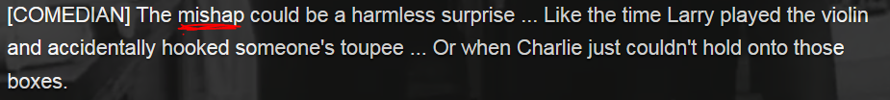









capitulate /kəˈpɪtjʊˌleɪt/ If you capitulate, you stop resisting and do what someone else wants you to do. 让步 = concede, yield ( If you yield to someone or something, you stop resisting them. 屈服) e.g. The club eventually capitulated/yielded and now grants equal rights to women. 该俱乐部最终让步，现在给予妇女同等的权利













## Stop mp3) Lexical resource

* Visually impaired e.g. **I’m visually impaired**. E.g I have **a severe visual impairment**.
* Are you joking? => I’m just kidding. **[ play a joke; tell a joke ]**
* Comedy: In the annual party, Jill and Tracy took a part in a funny **comedy show**.
* Humor: e.g. American are famous for their **humor traits（特性**）  
  e.g. I have **a good sense of humor**.
* **单相思** lovesick /ˈlʌvˌsɪk/ If you describe someone as **lovesick**, you mean that they are so in love with someone who does not love them, that they are behaving in a strange and foolish way. 单相思的
* **It's a bit of a pie in the face for us.  我们还真是有点丢脸了**
* outrageous /aʊt**ˈreɪ**dʒəs/ :  If you describe something as outrageous, you are emphasizing that it is unacceptable or very shocking. 不可接受的; 令人震惊的强调 By diplomatic standards, this was outrageous behaviour. 按外交标准，这是不可接受的行为。ADV 不可接受地; 令人震惊地 outrageously e.g. ..outrageously expensive skin care items.…贵得不可接受的护肤品 e.g.An **outrageous** joke can be shocking or **over the top (过分了，夸大了).**
* **(妥协)让步（投降）**
  + **capitulate /kəˈpɪtjʊˌleɪt/ , capitulation;** If you capitulate, you stop resisting and do what someone else wants you to do. 让步 = concede, yield
  + **yield:** If you **yield to** someone or something, you stop resisting them. 屈服) e.g. The club eventually **capitulated/yielded** and now grants equal rights to women. This is feminism we advocate. 该俱乐部最终**让步**，现在给予妇女同等的权利
* **名媛 debutante /ˈdɛbjʊˌtɑːnt/ debut, debutant;** A debutante is a young woman from a wealthy family who has started going to social events with other young people. 初进社交场合的年轻富家女子, 名媛
* routines ( in comedy) 成套动作(套路)  
  
* calamity大灾难 V.S. mishap. 小灾难, 不幸
  + **calamity**:  calamity is an event that causes a great deal of damage, destruction, or personal distress. 灾难 e.g. He described drugs as the greatest calamity of the age.
  + **mishap** /ˈmɪshæp/ A mishap is an unfortunate but not very serious event that happens to someone. 小灾难 **[ 身体缺陷 physical mishap ]** e.g. After a number of mishaps she did manage to get back to Germany. 发生了几次小的不幸之后，她设法回到了德国
* **笑话knee-slappers** = funny jokes V.S**. one-liner**
* **one-liner/one-line joke = witticism**: A one-liner is a funny remark or a joke told in one sentence, for example, in a play or comedy show. (戏剧、喜剧表演等中的) 单句俏皮话 e.g. The book is **witty诙谐幽默** and peppered with good **one-liners/ one-line jokes** 这本书**诙谐幽默**，**俏皮话**随处可见
* **punchline /ˈpʌntʃlaɪn/** The punchline of a joke or funny story is its last sentence or phrase, which makes it funny. 笑话或警句令人发笑**的最后一行**
* famous => **infamous** = **notorious** /nəʊˈtɔːrɪəs/   Infamous people or things are well-known because of something bad. 声名狼藉/臭名昭著的 e.g. He was **infamous/notorious** for his anti-feminist attitudes. 他因为他的反女权主义姿态而**臭名昭著**
* **disreputable**: If you say that someone or something is disreputable, you are critical of them because they are not respectable or cannot be trusted. 名誉不好的 e.g. ...the noisiest and most disreputable bars. ...最吵闹、名声最差的酒吧
* **notorious** /nəʊˈtɔːrɪəs/  notorious  [nəu'tɔ:riəs] having an exceedingly bad reputation . To be notorious means to be well known for something bad. 声名狼藉的 e.g. ...an area **notorious/infamous** for drugs, crime and violence. …一个因毒品、犯罪和暴力而**声名狼藉**的地区
* **Prime time** television or radio programmes are broadcast when the greatest number of people are watching television or listening to the radio, usually in the evenings. 黄金时段 e.g. ..a prime-time television show.…一个黄金时段的电视节目。
* Satire, satirist  美 ['s**ætə**rɪst] . 讽刺作家；爱挖苦的人 e.g. satire the politician, satire the communist party.
* If you say that someone, especially a child, is **a handful,** you mean that they are difficult to control. 难管的人 (尤指小孩) e.g. Zara can be **a handful** sometimes, so naughty. 扎拉有时会**很难管教(的小孩)** e.g. The little boy was **a real handful**. He **was always up to mischief**. 这个小男孩真是**难管教(的小孩)** 。他总是在**搞恶作剧/捣乱**
* put sb down: humiliate sb and make sb embarrassed (非正式)使sb窘迫, 奚落sb.   
  e.g. I hate it when you use **sarcasm** to **put other people down** (humiliate sb and make sb embarrassed. You might think it's clever, but I think it's mean.
* 恶作剧；诡计 hoax /həʊks/  ; prank; shenanigan

1. A hoax is a trick in which someone tells people a lie, for example that there is a bomb somewhere when there is not, or that a picture is genuine when it is not. 谎报 e.g. He denied making the hoax call but was convicted after a short trial. 他否认打过谎报电话，但经过一番短暂的审讯之后他被判有罪  
2. play hoax= play jokes, play pranks **[ practical jokes and pranks; e.g. a prank call 恶作剧电话]**

* shenanigan [ʃi'næniɡən]

1. **reckless** or **malicious** behavior that causes discomfort or annoyance in others 有恶意的恶作剧
2. the use of tricks to deceive someone (usually to extract money from them) **[ business scam; business shenanigan; business fraud ]**

* mischief /ˈmɪstʃɪf/

1.  Mischief is playing **harmless** tricks on people or doing things you are not supposed to do. It can also refer to the desire to do this. 恶作剧; 捣乱 [ sb. be up to mischief 搞恶作剧/捣乱； [keep sb. out of mischief](javascript:void(0);)不胡闹，不搞恶作剧 ] e.g. The little boy was **a real handful ( 难管的人 (尤指小孩)).** He **was always up to mischief**. 这个小男孩真是**难管教**。他总是在**搞恶作剧/**捣乱。

2.N Mischief is behaviour that is intended to cause trouble for people. It can also refer to the trouble that is caused. 制造的麻烦 e.g. The more sinister explanation is that he is about to make mischief in the Middle East again. 更为险恶的解释是他又要在中东制造事端

* Come at sb. （气冲冲的）朝sb走过来 e.g. When he steals cookies, his mother **comes at him**  
  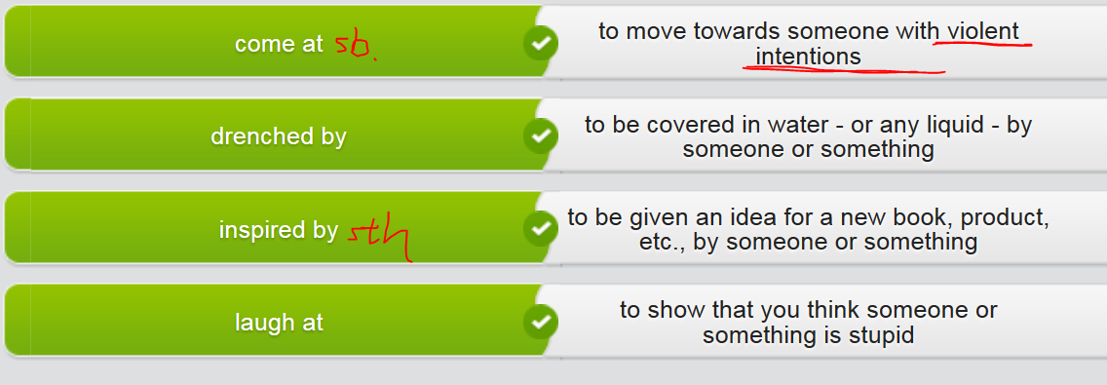
* **[ drenching rains 滂沱大雨 V.S. torrential rain (倾盆大雨 downpour) V.S. drizzle 下毛毛雨 ]** To **drench** something or someone means to make them completely wet. 使xxx湿透 (使湿身）； 把sb.浇湿 **Drenching rains**: strong rains with tremendous volume of precipitation 降雨量 e.g They turned **fire hose**s on the people and **drenched them**. 他们打开消防水龙头朝人群喷去，把他们浇湿。 e.g. Officials are still concerned areas in eastern North Carolina that were recently flooded will see **drenching rains滂沱大雨** from Hurricane Matthew e.g. The torrential rains **drenched me** completely. 暴雨把我淋成了落汤鸡/彻底湿透了。

## Degree of “Funny”:

1. amusing
2. Witty
3. Hilarious
4. Hysterical: you laugh so much, you cannot even breathe.

## Degree of “laugh”:

1. giggle
2. chuckle
3. crack sb. up
4. split my sides

|  |  |
| --- | --- |
| (窘的)轻声窃笑 | **titter** /ˈtɪtə/  1.V-I If someone **titters**, they give a short nervous laugh, especially when they are embarrassed about something. (窘的)轻声窃笑 e.g. Mention sex therapy and most people will **titter** in embarrassment. 提到性疗法，许多人会尴尬地窃笑。 2. Titter is also a noun. e.g. Mollie gave an uneasy little **titter**. 微微窃笑了一下。 3. (窘的) 轻声窃笑 tittering= the sound of titter e.g. There was nervous tittering in the studio audience. 演播室观众席中传来紧张的窃笑声 |
| (不礼貌不尊重的) 窃笑 | snigger  1.V-I If someone **sniggers**, they laugh **quietly in a disrespectful way**, for example at something rude or unkind. (不礼貌不尊重的) 窃笑 e.g. Suddenly, three schoolkids sitting near me started sniggering. 3个学童偷偷地笑了起来。  =》 2.N-COUNT Snigger is also a noun. 窃笑 e.g. ...trying to **suppress a snigger**. …极力按捺一阵窃笑。 |
| 轻声地笑 | chuckle ['tʃʌkl]  1.V-I When you **chuckle**, you laugh **quietly**. 轻声地笑 e.g. The banker chuckled and said, "Of course not." 银行家轻声笑了，说道，“当然不。”  2.N-COUNT Chuckle is also a noun. E.g gave a little chuckle. 他轻声一笑 |
| 咯咯地笑 | giggle /ˈɡɪɡəl/  1.V-T/V-I If someone giggles, they laugh in a childlike way, because they are amused, nervous, or embarrassed. 咯咯地笑 e.g. Both girls began to **giggle**. 两个女孩都咯咯地笑起来。  "I beg your pardon?" she giggled. E.g. 对不起，你说什么？”她咯咯地笑着问。  2. Giggle is also a noun. 咯咯的笑 e.g. She **burst into the giggles**. 她咯咯地笑了一下。  3. If you say that someone **has the giggles**, you mean they cannot stop giggling. 咯咯笑个不止 e.g. I was so nervous I **got the giggle**s. 我紧张得咯咯笑个不 |
| 不雅地大笑 | cackle  /ˈkækəl/  1.V-I If someone **cackles**, they laugh in **a loud unpleasant way**, often at something bad that happens to someone else. (当坏事发生在他人身上时)不雅地大笑 e.g. The old lady **cackled**, pleased to have produced so dramatic a reaction. 老太婆刺耳地笑  2.N-COUNT Cackle is also a noun. E.g. He let out a brief cackle. |
| 捧腹大笑n | a belly laugh |
| 笑屎了；笑掉大牙 | I was **laughing my head off.**  They were **laughing their heads off.** |

## Genres of comedies 喜剧有很多类型或流派

* + **dry jokes or dry humo**r: 冷幽默的表达方式:in the dry or neutral way,dry: plain, matter-of-fact. e.g. Her ironic humor is so funny/hilarious because of the **dry** way she delivers it.
  + **corny joke**s: 陈腐的；乡下味的old joke that have been used/repeated so many times, so that that joke is not funny at all.
  + **dirty jokes**: involve some nasty, pornographic story, rude words.

|  |  |
| --- | --- |
| 滑稽戏 **Slapstick** is a very **physical** type of comedy, like slipping on a banana peel or bumping into glass window **[ slapstick comedy** ] e.g. **Charlie Chaplin** is still well-known for his **[ slapstick comedy ].**  **Slapstick** is a simple type of comedy in which the actors behave in a rough and foolish way. 闹剧; 滑稽戏 | **滑稽戏是一种肢体动作明显的喜剧**，比如踩到香蕉皮滑倒。 |
| 黑色幽默**Black/dark humor** takes an **unhappy** event and presents it in a funny way, just to be optimistic. E.g.talking about death, funeral | 黑色幽默用滑稽的方式呈现一个**不幸的事件**。 |
| 恶搞,恶作剧A **practical joke** is a funny trick or prank/hoax/shenanigan that is a little mean or embarrassing. **[ practical joke and pranks; 令人捧腹的恶搞 hilarious practical jokes and pranks]** | 恶作剧是一种滑稽的把戏或玩笑，往往**有点刻薄或让人尴尬**。 |
| 双关语 A **pun** uses different possible meanings of a word or several words that sound alike but have different meanings. A pun is a clever and amusing use of a word or phrase with two meanings, or of words with the same sound but different meanings. V to make puns 说双关语  **[clever pun 巧妙的双关]** | 双关语用的是**一词多义**或**多个同音词有异义词**。 |
| 讽刺**Sarcasm** is when what someone says is the complete opposite of what they mean. | 讽刺是指说的是和自己的意图完全相反的话。 |
| 单口相声**Stand-up comedy** is a style of comedy where a comedian performs in front of a live audience.  e.g. There’s **a stand-up comedian单口喜剧演员**, and my sources tell me he is about to **go stellar.** 有个单口喜剧演员，据我所知他很快就要**走红/出名**了 //**〔流行乐队、演员等〕走红. 出名, 变得极受欢迎: go stellar ]** informal if a pop band, actor etc goes stellar, they become very popular and famous. | 单口相声是喜剧演员在听众前面现场表演的一种喜剧。 |
| 双簧? |  |
| 情景喜剧sitcome=situation comedy |  |
| **一种短小的系列喜剧 sketch comedy**  A sketch comedy comprises a series of short comedy scenes or vignettes, called "sketches", commonly between one and ten minutes long. Such sketches are performed by a group of comic actors or comedians, either on stage or through an audio and/or visual medium such as broadcasting. |  |

有些著名的喜剧演员尤其特定的喜剧模式

|  |  |
| --- | --- |
| **Charlie Chaplin** is still well-known for his **[ slapstick comedy ].** | 卓别林至今仍以**滑稽戏**著称。 |
| **Jerry Seinfeld** had a very successful **situation comedy (sitcom)** called Seinfeld. | 宋飞有一部非常成功的**情景喜剧（sitcom）**叫做Seinfeld（宋飞正传）。 |
| **Jim Carrey** is well-known for his hilarious **[ practical jokes and pranks. ]** | 金凯瑞以其**令人捧腹的**恶搞著称。 |

e.g. Some joke examples

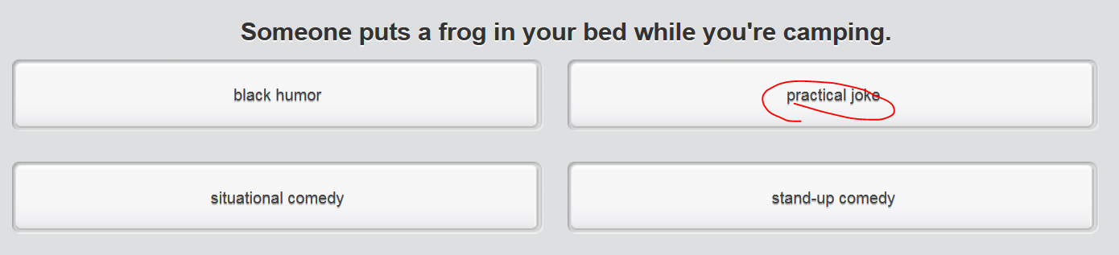

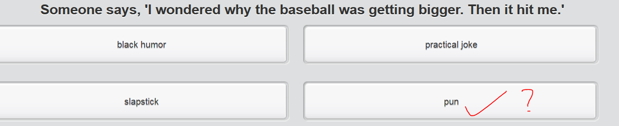

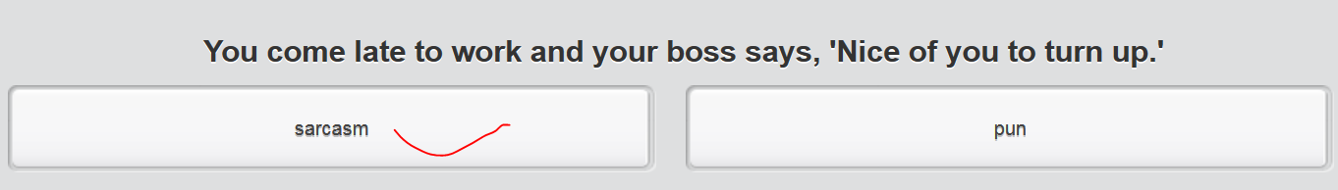

* I hate it when you use **sarcasm** to **put other people down** (humiliate sb and make sb embarrassed (非正式)使sb窘迫, 奚落sb. You might think it's clever, but I think it's mean.
* My favorite **pun** is an ad campaign in a camping store window: ‘Now is the winter of our **discount tents,**’ a play on the Shakespearian line: ‘Now is the winter of our discontent.‘   
  //pun用的是**一词多义**或**多个同音词有异义词**。
* I know some people find it offensive, but I think it's important that we can laugh at the difficult and painful or unhappy things in life: **black humor** is an important way of dealing with tragedy.
* There's nothing better than some good old-fashioned **slapstick comedy**. A custard pie in the face always makes me laugh. //滑稽戏,是一种肢体动作明显的喜剧

**Stand-up comedy** 单口相声is great entertainment. The way the comedian reacts to the audience can really increase the humor. E.g. e.g. There’s **a stand-up comedian单口喜剧演员**, and my sources tell me he is about to **go stellar.** 有个单口喜剧演员，据我所知他很快就要**走红/出名**了

* My son is always playing **practical jokes and pranks** on me. Yesterday he hid a plastic frog in my shoe! 恶搞,恶作剧

Mp3 done



## 2nd row

An **outrageous** joke can be shocking or **over the top (过分了，夸大了).**

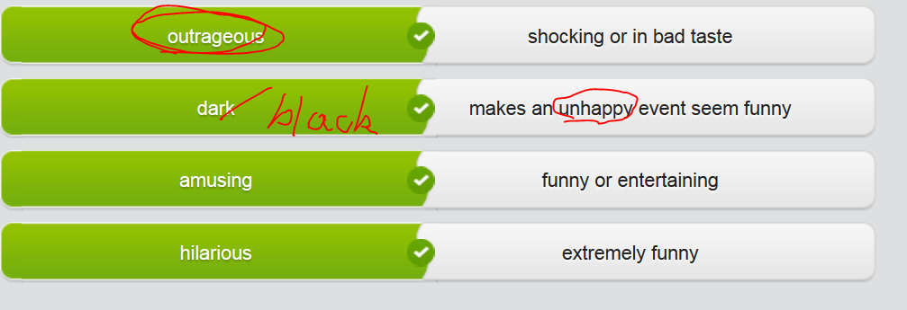

## 3rd row: prepositions (by, at)

很多表达需要依靠一个特定的介词prepositions。请看这些带 **at**的例句.

|  |  |
| --- | --- |
| As soon as I entered the yard, the dog **came at** me!  When he steals cookies, his mother **comes at him！** | 我一进到院子里，狗就**冲我走了过来了**！ |
| No one likes to be laughed **at.** | 没人喜欢被嘲笑。 |

请看这些带**by**的被动句

|  |  |
| --- | --- |
| We were having a picnic outside and got **drenched by** the **torrential rain**.  The man on the beach **was drenched by** the wave. | 我们在野餐时**让暴雨给淋湿了**。 |
| Everyone **was inspired by** the story of her amazing life. | 每个人都从她的故事中 **得到了启发**。 |
| I learned my lesson. I won't be fooled by her again. | 我得到教训了。我再也不会被她骗了。 |

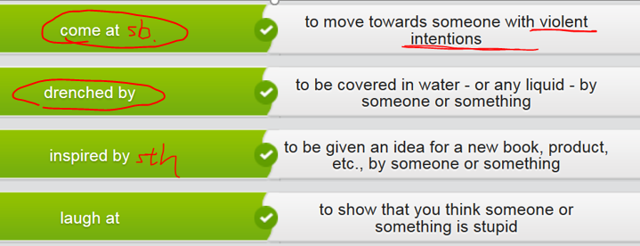

Mp3 done



## 4th row

Discussing different types of comedy. Your friend is a big fan of comedy. Listen as she talks about her favorite comedians, shows and kinds of comedy.

# Part 2) Perform a comedy act

## 1st row

## Stop (to record mp3) ＝＝ Lexical resources

* hitman /ˈhɪtmæn/  hitman is a man who is hired by someone in order to kill another person. 职业杀手
* 笑是良药Laughter is the best medicine.
* 同某人一起大笑 laugh **with** sb
* 嘲笑 laugh **at** sth
* **笑死人了,** 牙都笑掉了**I was laughing my head off  = to die laughing   
  e.g. He laughed his head off; They laughed their heads off**
* 令人捧腹(大笑)的（故事，笑话）hilarious /hɪˈlɛərɪəs/    
  1.ADJ If something is hilarious, it is extremely funny and makes you laugh a lot. 令人捧腹大笑的 **[ 令人捧腹的恶搞 hilarious practical jokes; hilarious pranks; hilarious jokes; hilarious story ]** We thought it was hilarious when we first heard about it. 我们第一次听说这件事的时候觉得它很可笑。   
  2.ADV 令人大笑地 hilariously e.g. She found it hilariously funny. 她觉得这事儿滑稽极了 e.g. Jim Carrey is well-known for his hilarious **practical jokes and pranks**.
* **令人捧腹大笑的(演出; 表演): laug[h-o]ut-loud (lol)/side-splitting** e.g.  Something that is side-splitting is very funny, so **hilarious** and makes you laugh a lot. 令人捧腹大笑的
  + **laug[h-o]ut-loud ( lol ) performance = side-splitting performance令人捧腹大笑的演出 [捧腹大笑：I have a belly laugh]**
  + **laugh-out-loud talk show = a side-splitting talk show**
  + **side-splitting laugher:**
  + **You joke always made me split my side! 令我捧腹大笑/笑jue过去了。**

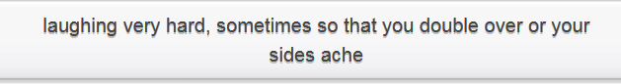

* **笑在最后; 取得最后胜利 get the last laugh** e.g. Well, let’s see who **will get the last laugh.**
* **Laugh and the world laughs with you, cry and you cry alone!**

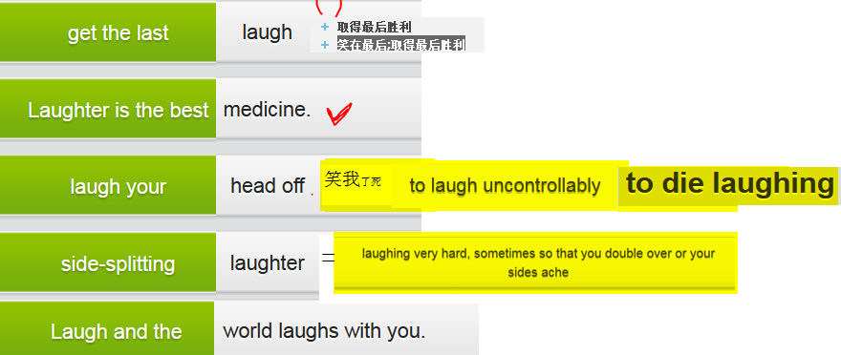

* You just got spaghetti sauce on your shirt. Your brother is laughing. Then he accidentally dumps a glass of water in his lap. You just **got the last laugh** .
* You are laughing so hard at your brother, your sides hurt. This is **side-splitting laughter**.
* Your closest friend is having a bad day, so you tell her a joke that cheers her up. This is proof that **laughter is the best medicine** .
* Your neighbor always has a positive optimistic attitude, even when things don't go right for her. She's an example of this phrase: **laugh and the world laughs with you, cry and you cry alone.**
* That poor girl. Everyone is always **making fun of her** .
* The movie was great and hilarious. I was **laughing my head off** the whole time.

## Stop (to record mp3) ＝＝ Types of laugh

|  |  |
| --- | --- |
| (窘的)轻声窃笑 | **titter** /ˈtɪtə/  1.V-I If someone **titters**, they give a short nervous laugh, especially when they are embarrassed about something. (窘的)轻声窃笑 e.g. Mention sex therapy and most people will **titter** in embarrassment. 提到性疗法，许多人会尴尬地窃笑。 2. Titter is also a noun. e.g. Mollie gave an uneasy little **titter**. 微微窃笑了一下。 3. (窘的) 轻声窃笑 tittering= the sound of titter e.g. There was nervous tittering in the studio audience. 演播室观众席中传来紧张的窃笑声 |
| (不礼貌不尊重的) 窃笑 | snigger  1.V-I If someone **sniggers**, they laugh **quietly in a disrespectful way**, for example at something rude or unkind. (不礼貌不尊重的) 窃笑 e.g. Suddenly, three schoolkids sitting near me started sniggering. 3个学童偷偷地笑了起来。  =》 2.N-COUNT Snigger is also a noun. 窃笑 e.g. ...trying to **suppress a snigger**. …极力按捺一阵窃笑。 |
| 轻声地笑 | chuckle ['tʃʌkl]  1.V-I When you **chuckle**, you laugh **quietly**. 轻声地笑 e.g. The banker chuckled and said, "Of course not." 银行家轻声笑了，说道，“当然不。”  2.N-COUNT Chuckle is also a noun. E.g gave a little chuckle. 他轻声一笑 |
| 咯咯地笑 | giggle /ˈɡɪɡəl/  1.V-T/V-I If someone giggles, they laugh in a childlike way, because they are amused, nervous, or embarrassed. 咯咯地笑 e.g. Both girls began to **giggle**. 两个女孩都咯咯地笑起来。  "I beg your pardon?" she giggled. E.g. 对不起，你说什么？”她咯咯地笑着问。  2. Giggle is also a noun. 咯咯的笑 e.g. She **burst into the giggles**. 她咯咯地笑了一下。  3. If you say that someone **has the giggles**, you mean they cannot stop giggling. 咯咯笑个不止 e.g. I was so nervous I **got the giggle**s. 我紧张得咯咯笑个不 |
| 不雅地大笑 | cackle  /ˈkækəl/  1.V-I If someone **cackles**, they laugh in **a loud unpleasant way**, often at something bad that happens to someone else. (当坏事发生在他人身上时)不雅地大笑 e.g. The old lady **cackled**, pleased to have produced so dramatic a reaction. 老太婆刺耳地笑  2.N-COUNT Cackle is also a noun. E.g. He let out a brief cackle. |
| 捧腹大笑n | a belly laugh |
| 笑屎了；笑掉大牙 | I was **laughing my head off.**  They were **laughing their heads off。** |

## Stop (to record mp3) ＝＝ Reading

|  |  |
| --- | --- |
| My grandmother was a wise woman. She was always giving me advice without me realizing it. When I was a teenager and feeling sorry for myself all of the time, “My dear,” she’d say, “**laugh and the world laughs with you, cry and you cry alone**.” And then I’d cheer up, because I knew she was right.  Then, when I was a little older and I did have real problems from time to time, she’d tell me, “**Laughter is the best medicine**, you know.” I had to hug her then. One time I replied, “Ah, Grandma, if only I had something good to laugh at right now.” The next day she came over to my house in the evening and turned on the TV without even greeting me. I was so surprised, she’d tuned in to the movie channel before I had a chance to ask her what she was doing. And then I saw that they were playing an old classic comedy that evening.  “Be prepared for some **side-splitting(lol) laughter**, my dear,” she said with an amused smile on her face. | Then we watched It's a Mad Mad Mad Mad World, and Grandma was right. We **laughed our heads off.** Honestly, I could die laughing just thinking back to that evening. So that’s what I do whenever things get rough. I remember the silly people in the film and think about how Grandma used them to **poke fun at people** that made us angry. Crazy and mean drivers, for instance, we called ‘Smilers’ after the bad driver in the movie.  Really. My grandma was right: It always helps to **make fun of** life’s minor troubles. If you do, you just might be the one to **get the last laugh!** |

## 2nd row map3 done

## 3rd row **理解常见的笑话**

笑话在翻译中是难题之一。此外，每种文化都有其特定的标准或常见笑话。最常见的两种笑话是 **knock, knock** 和 **guy walks into a bar**。注意，**knock** 是你弯曲指关节敲门的声音

|  |  |  |
| --- | --- | --- |
|  | | A: **Knock, knock!** B: **Who's there?** A: Doris. B: Doris who? A: Doris locked. That's why I'm knocking! |
|  |  |  |
|  | |  |

|  |  |
| --- | --- |
|  | **A guy walks into a bar.** He asks the bartender: 'Do you have any helicopter-flavored potato chips?' The bartender shakes his head and says: 'No, we only have plain (原味的).' |

|  |  |
| --- | --- |
|  |  |

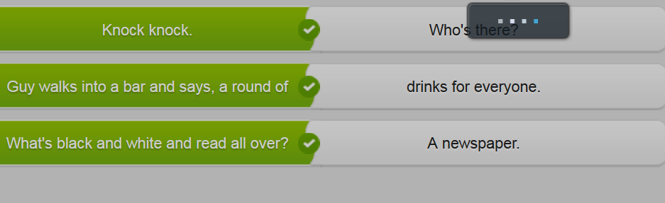

# Part 3) April Fools’ day （愚人节）

## 1st row

## Video





**A strand of** something such as hair, wire, or thread is a single thin piece of it. (头发、电线或纱线的) 缕

 

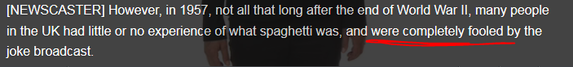







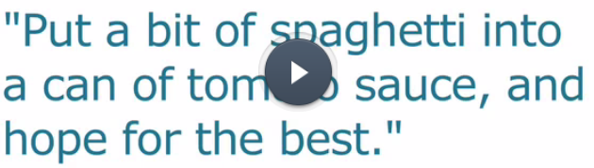





**认真的风格 no-nonsense style**





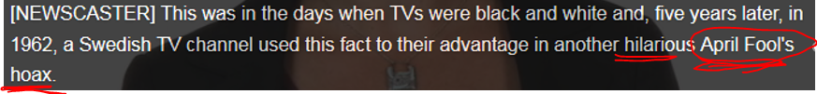

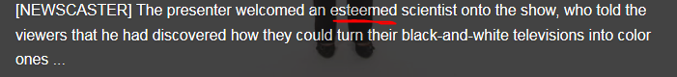

 nylon: **/ˈnaɪlɒn/**

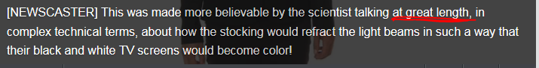



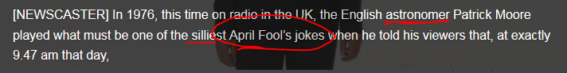

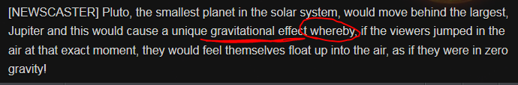

Whereby = by which 凭借xxx; zero gravity: 零重力；失重







## Stop (to record mp3) ＝＝ Lexical resources:

* awful V.S. awesome
  + awful /ˈɔːfʊl/   1.ADJ If you say **that someone or something is awful = nuisance 讨厌的人；损害；麻烦事；讨厌的东西,** you dislike that person or thing or you think that they are not very good. 令人讨厌的人/事情 e.g. We met and I thought he was awful, such a **nuisance**. 我觉得他令人讨厌。 ...an awful smell of paint. …**一股难闻/令人讨厌的**油漆味。

2.ADJ If you say that something is **awful**, you mean that it is extremely unpleasant, shocking, or bad. 糟透的 e.g. Her injuries were massive. It was awful. 她的伤势很严重，糟透了。  
3.ADJ If you **look or feel awful**, you look or feel ill. 难受的 E.G. I hardly slept at all and **felt pretty awful.** 我几乎没睡，**感觉挺难受。**

4.ADJ You can use awful with noun groups that refer to an amount in order to emphasize how large that amount is. 极度的强调 E.G. I've got an awful lot of work to do. 我有极多的工作要做。 5.ADV 极度地 awfully E.G. the caramel looks awfully good. 看上去棒极了

* + awesome 令人畏惧的; 棒极了的，牛/ˈɔːsəm/    
    ADJ An awesome person or thing is very impressive and often frightening. 令人畏惧的 e.g. ...**the awesome responsibility** of sending men into combat. …派士兵去打仗的**令人畏惧的责任**。

ADJ If you describe someone or something as awesome, you are emphasizing that you think that they are very impressive or extraordinary, fantastic, fabulous棒极了的，牛

E.g. Melvill called the flight "mind-blowing" and "awesome." “无比兴奋”、“棒极了”。

* 冷幽默的表达方式:in the dry way,dry:plain, matter-of-fact e.g. Her ironic humor is so funny/hilarious because of the **dry** way she delivers it.
* **尖酸刻薄 e.g His remarks are very harsh, cutting and barbed.**
* **用另一种 方式来解释，诠释 /**改述 **paraphrase /ˈpærəˌfreɪz/**

1.If you **paraphrase someone or paraphrase something** that they have said or written, you express what they have said or written **in a different way.**  e.g. To **paraphrase President Bush**, we must restore confidence in our economic sector. 布什总统的意思是…。 E.g. HE paraphrased the contents of the press release. **重新解释**了新闻发布的内容。

2. **A paraphrase of something** written or spoken is the same thing expressed in a different way. 释义; 改述 e.g. The last two clauses were an exact quote rather than a paraphrase of Mr. Forth's remarks. 最后两个分句是对福思先生言论的准确引用而不是改述。

* whereby = by which 凭借xxx; 据此 e.g The company operates an arrangement **whereby** employees may select any 8-hour period between 6 a.m. to 8 p.m. to go to work. 该公司做出了一种安排，**据此**员工可以在上午6点到晚上8点之间任意选择8个小时去上班
* **零重力；失重** **zero gravity** e.g. I’m in **zero gravity**
* strand /strænd/     
  1.  **A strand of something** such as hair, wire, or thread is a single thin piece of it. (头发、电线或纱线的) 缕 **[ a strand of hair; a strand of wires; a strand of nylon 一缕尼龙绳]** e.g. She tried to blow **a grey strand of hair** from her eyes. 一缕白发。

2. If you **are stranded**, you are prevented from leaving a place, for example because of bad weather. 使滞留 （机场，火车站） e.g. The climbers had **been stranded** in hillside by a storm. 这些登山者**滞留**在半山腰。 E.g. More than 1000 passengers **were stranded** in Heatheral airport because of an IT system malfunction.

**3. to form (a rope, cable, etc) by winding strands together 搓; 绞(绳索等)成一缕**

4.V to leave or drive (ships, fish, etc) aground or ashore or (of ships, fish, etc) to be left or driven ashore 使(船、鱼等)搁浅

* nylon /ˈnaɪlɒn/  Nylon is a strong, flexible artificial fibre. 尼龙 [**a strand of nylon 一缕尼龙绳**] ; The chair is made of lightweight nylon. 那把椅子是由轻质尼龙制作的。

2.N-PLURAL **Nylons** are stockings made of nylon. 尼龙袜 e.g. She wore a long skirt with pink pumps and black **nylons. 尼龙袜**

* pasta:  /ˈpæstə/  Pasta is a type of food made from a mixture of flour, eggs, and water that is formed into different shapes and then boiled. **Spaghetti**, **macaroni**/ˌmækəˈrəʊnɪ/  , and noodles are types of pasta. 面食
  + spaghetti /spəˈɡɛtɪ/  Spaghetti is a type of pasta. It looks like long pieces of string and is usually served with a sauce. 意大利式细面条
  + macaroni: /ˌmækəˈrəʊnɪ/ Macaroni is a kind of pasta made in the shape of short, hollow tubes. 通心面
* **April Fool’s day 愚人节=> April Fool’s joke 愚人节玩笑=> April Fool’s hoax/prank恶作剧**

e.g. An **April Fool's joke** can only be told on the first day of that month.

* 愚弄 sb be fooled by sth
* **笑话广播 (n) joke broadcast** e.g. Many people believed **the joke broadcast** because the BBC is well-respected.
* **认真的风格 no-nonsense style** e.g. She told the **April Fool's joke** in **a no-nonsense style** and everyone believed her.
* **可信的 believable;• believably** e.g. The trick to telling a good April Fool's joke is to tell it **believably**

## 2nd row Sarcasm **反讽**and implied meaning**寓意**

**反讽和寓意:**

* **反讽**Sarcasm, sarcastic  [sɑ:'kæztik] 是指某人说的和他的真实意思完全相反，挖苦; 讽刺 以达到取笑 laugh at/make fun of sb或侮辱 mock or insult的目的。Sarcasm is speech or writing which actually means **the opposite of what it seems to say.** Sarcasm is usually intended to mock or insult someone.例：Sarcasm and demeaning remarks have no place in parenting.挖苦和贬损的言语不应用来教育子女
* **寓意:** 如果话中有话，这就是一个 **implied meaning** 的例子。

e.g 你朋友问了你一个问题，你**sarcastically** 地回答：虽然反讽可以很好笑，但还可能会伤害别人。所以使用的时候要小心。

|  |  |  |
| --- | --- | --- |
|  | A: Don't you think this guy is really funny? | 你不觉得这家伙真的很搞笑吗？ |
| B: **Hilarious**. Can't you see **that I'm laughing my head off**? (based on sarcastic tone) | 太好笑了，你没看见**我牙都笑掉了/笑死了**吗？ |
| A: You don't have to be so **sarcastic**. | 你没必要这么挖苦吧。 |
|  | | |
|  |  |  |

|  |
| --- |
|  |

**Sarcasm** 是 **irony** 的一种。二者之间一个比较大的差别是反讽总是用在讲话当中，讽刺可以用于事情的结果和所有人料想的完全相反的情况。比如，外面在下大雨，你**ironically** 地说：**irony, ironical, ironically**

|  |  |
| --- | --- |
| Isn't it a beautiful day out? | 外面天气真好啊，不是吗？ |

反讽sarcasm和幽默有许多不同的使用方式。

|  |  |
| --- | --- |
| His **remark** was so **sarcastic** that his colleague started crying. | 他的评论太挖苦了，惹得他的同事都哭起来了。 |
| That sarcastic remark was **harsh, cutting/hurtful, and barbed**. | 那段挖苦的评论极其 尖酸刻薄。 |
| Her ironic humor is so funny because of **the dry way** she delivers it. | **冷幽默的表达方式**让她的讽刺式幽默显得极为有趣。 |
| He's so charming. Everything he says has great **wit**. | 他太迷人了。他说的每一句话都闪烁着 **诙谐幽默**。 |
| It's **incredible**. She's always ready with a **comeback**. | 难以置信。她时刻准备着**复出**。 |

|  |
| --- |
|  |

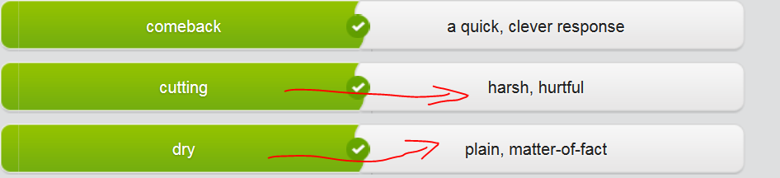

## 3rd row Quoting and paraphrasing

paraphrase /ˈpærəˌfreɪz/

1.V-T If you **paraphrase someone or paraphrase something** that they have said or written, you express what they have said or written **in a different way**. 用另外一种方式释义; 改述别人说的事情 e.g. To **paraphrase President Bush**, we must restore confidence in our economic sector. 布什总统的意思是，我们XXX。 E.g. Baxter **paraphrased the contents of the press release**. 巴克斯特解释了新闻发布的内容。

2.N-COUNT A paraphrase of something written or spoken is the same thing expressed **in a different way**. 释义; 改述 e.g. The last two clauses were an exact quote rather than a paraphrase of Mr. Forth's remarks. 最后两个分句是对福思先生言论的准确引用而不是改述。

## Stop (to record mp3) ＝＝ Famous quotes

I like to quote Oscar Wilde. As I always say after staying out late (熬夜其晚后)**, 'Only** 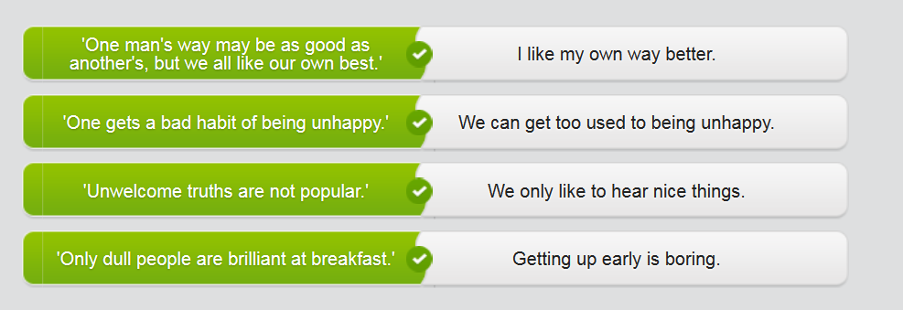

* My mother often quotes Mark Twain. She says that **a full belly is little worth where the mind is starved.**
* Mark Twain also once said that **nothing so needs reforming as other people's habits**.
* Jane Austen once wrote that **one man's ways may be as good as another's, but we all like our own best.**
* As Henry James once said - **To read between the lines was easier than to follow the text**.
* **dull people are brilliant at breakfast!'**

Choose the correct quote to respond to each of the situations below.

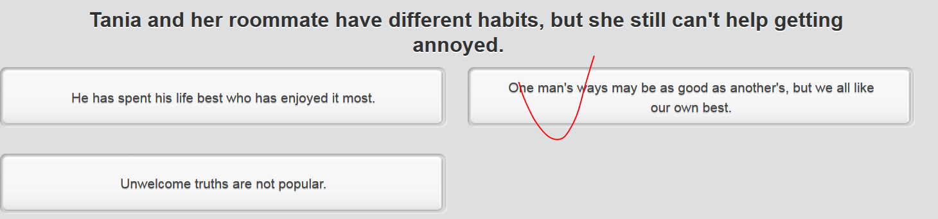

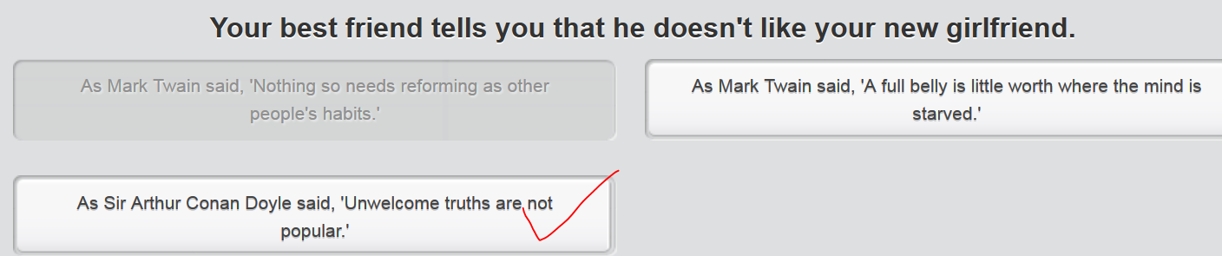

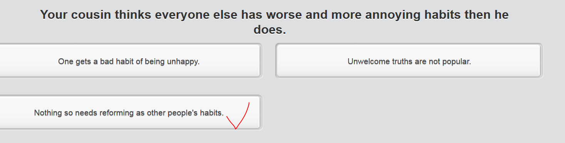

?自己所不于，勿适于人

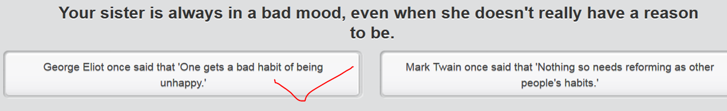

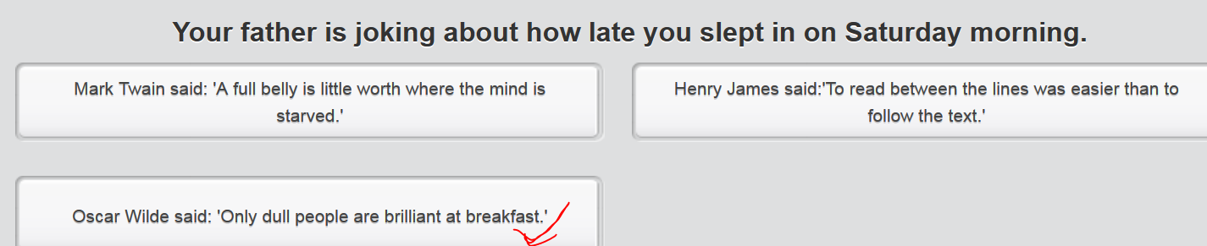

## 4th row video

Your manager has just given a presentation on the recent drop in sales. You thought the presentation was terrible! You and your colleagues dislike your manager. One colleague is **making sarcastic remarks** in the staffroom. Respond with the most sarcastic reply.

# Part 4 ) Write a funny story

How to write a funny story: use sarcasm, humor, **witty** way

## Video: A good come-back







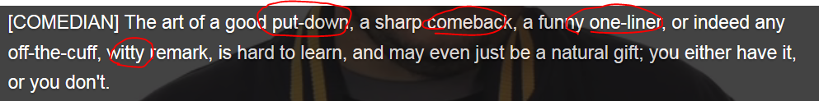







 



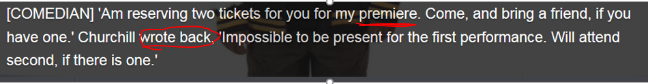











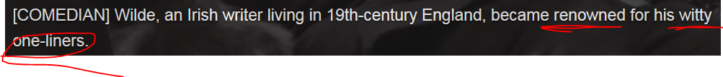

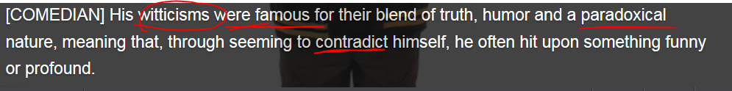



 









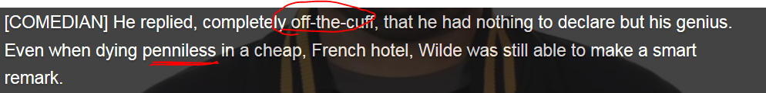









## Stop (to record mp3) ＝＝ Lexical resources:

* **空运sth: airlift sth: deliver sth by plane** e.g. [Why Qatar is airlifting in cows](http://money.cnn.com/2017/07/12/news/qatar-flying-cows-milk-shortage/index.html?iid=surge-toplead-intl)  e.g It’s not allowed to airlift pets, such as dogs or cats.
* **不良的抵押贷款 toxic mortgage e.g.** The Royal Bank of Scotland has agreed to pay $5.5 billion to settle claims that it sold **toxic mortgages** (risky loans**不良的抵押贷款)** prior to the financial crisis. RBS has already **set aside** most of the funds needed to resolve allegations made by the Federal Housing Finance Agency that it packaged and sold **risky loans (that is toxic mortgages)** worth over $30 billion to U.S. mortgage giants Fannie Mae and Freddie Mac.
* **容忍xxx put up with (putting,puts)** If you put up with something, you **tolerate** or **accept** it, even though you find it unpleasant or unsatisfactory. 容忍 They had **put up with** behaviour from their son which they would not have tolerated from anyone else.**容忍**了自己儿子的行为
* **解决处理(的方法) e.g.** A federal judge granted preliminary approval over the weekend for Wells Fargo's [$142 million national class action settlement](http://money.cnn.com/2017/04/21/investing/wells-fargo-expands-customer-settlement/index.html?iid=EL)解决处理(的方法). The court ruled that the settlement, which covers [fake/ **bogus['bəʊgəs]伪造的accounts** back to 2002](http://money.cnn.com/2017/04/10/investing/wells-fargo-board-investigation-fake-accounts/index.html?iid=EL), "fair, reasonable and adequate." Victims may still have to wait before they get paid. The bank and lawyers for the **plaintiffs/indictor/accuser** plan to reach out to customers in the next three months, but the **settlement解决处理(的方法).** may not be final until early 2018.
* **bogus['bəʊgəs]伪造的accounts**
* **bailout: financial bailout =v) bail sb out(常通过提供资金) 帮助…摆脱困境**　e.g. RBS, formerly the largest bank in the world, was **bailed out** by the British government in 2008. The government still owns more than 70% of the firm, which has reported nine consecutive years of losses totaling £58 billion ($74.7 billion). **// be released on bail 保释 //n)**
* parkour  [u:] 跑酷 （一种极限运动）
* drinkable /ˈdrɪŋkəbəl/

1.ADJ Water that is drinkable is clean and safe for drinking. 可饮用的 e.g. ...the pumping stations that provide the main supply of drinkable water for the region. ...为该地区提供主要饮用水的泵站。

2.ADJ If you say that a particular wine, beer, or other drink is drinkable, you mean that it tastes quite pleasant. 好喝的 e.g. The food was good and the wine drinkable. 这饭菜好吃，酒也好喝

* stunt /stʌnt/

1. 引人注目的噱头 A stunt is something interesting or funny that is done in order to attract public attention and get publicity for the person or company responsible for it. **[（影片,小说）宣传噱头 promotional stunt ]**e.g. In a bold **promotional stunt** for the movie, he smashed his car into a passing truck. 在那部影片大胆的**宣传噱头**中。
2. (电影中的) 特技动作 A stunt is a dangerous and exciting piece of action in a movie, stunt => **stunt man特技表演者; 特技替身演员**: A stuntman is a man whose job is to do dangerous things, either for publicity, or in a movie instead of an actor so that the actor does not risk being injured. E.g. Sean Connery insisted on living dangerously for his new film by performing his own **stunts**. 表演他自己的**特技动作**而冒险。
3. V to perform a stunt or stunts 表演杂技
4. 阻碍 If something **stunts the growth or development of a person or thing**, it prevents or **hinder/hamper** it from growing or developing as much as it should. e.g. The heart condition had stunted his growth a bit. 心脏病已经有点儿阻碍他的发育。4.ADJ 受阻碍的 stunted **[ 生长受阻 stunted growth; 发展受阻 stunted development ]** e.g. Damage may result in **stunted growth** and sometimes death of the plant. 损害会导致植物生长受阻，有时还会导致死亡。 E.g. The PM’s **oversight** 疏忽results in the **stunted development** for our new project.

* genie ['dʒiː**nɪ**]（有魔法的）妖怪；鬼: ghost, monster, goblin(妖怪)

1. In stories from Arabia and Persia, a **genie** is a spirit which appears and disappears by magic and obeys the person who controls it. (阿拉伯和波斯神话故事中的)魔仆

2. 魔仆出瓶(尤指产生不良影响的事件的发生): If you say that **the genie is out of the bottle** or that **someone has let the genie out of the bottle**, you mean that something has happened which has made a great and permanent change in people's lives, especially **a bad change**.

* 天生是(做什么的xxx) ; 天生注定**xxxx [ be born to do ]** e.g. **Was he born to** be successful, or did he just **luc[k o]ut?** 他是**天生注定**成功，还是**侥幸成功**呢？
* 走好运, 侥幸成功, 逢凶化吉**luc[k o]ut:** If you **luck out**, you get some advantage or are successful because you have good luck.

e.g. **Was he born to** be successful, or did he just **luck out?** 他是**天生注定**成功，还是**侥幸成功**呢？

* unicycle 单轮车；独轮脚踏车  one-wheeled vehicle driven by pedals, esp one used in a circus, etc 独轮车 (Also called monocycle)
* n) 下马威，使对方不再做声的反驳；贬低奚落的行为  A **put-down** is something that you say or do to criticize someone or make them appear foolish or make them afraid to insult or mock you. **[ a good put-down 很好的一个下马威，使对方不再做声]**  
  e.g. I see this term as a put-down of women. 我认为该措辞有贬低妇女之嫌。 e.g. She's always ready with **a good put-down** for anyone who insults or mocked her. e.g. She insulted and **mocked嘲弄 him**, but he was ready with a great witty **comeback(诙谐的回击),** giving her **a good put-down**
* [美国俚语]即兴地，临时地 **off-the-cuff:** with little or no preparation or forethought,  [**impromptu**](javascript:void(0);) **[off-the-cuff, witty remarks] [ off-the-cuff, hilarious jokes ] = impromptu party; impromptu performance.**
* 尖酸刻薄的(comments, critics, remarks) cutting = hurtful, harsh, barbed
* 前沿, 尖端技术cutting-edge (technology, equipment) :   
  1.N-SING If you are **at the cutting edge of** a particular field of activity, you are involved in its most important or most exciting developments, normally **at the forefront of** that field **[ 位于(…技术)的前沿 at the cutting edge of sth = at the forefront of sth ]** e.g. This shipyard is **at the cutting edge/forefront of** world shipbuilding technology. 这家造船厂**位于**世界造船技术**的前沿**。

2. **cutting-edge techniques or equipmen**t are the most advanced that there are in a particular field. 前沿的尖端技术，尖端设备) e.g. What we are planning is **cutting-edge technology** never seen in Australia before. 前所未见的尖端技术  
3. V.S. highly **sophisticated** equipment **高精密**的仪器。

* comeback n, come back v

1. If someone such as an entertainer or sports personality **makes a comeback**, they return to their profession or sport after a period away. 复出 eg. Sixties singing star Petula Clark is making a comeback.

60年代的歌星要复出了。

2. If something **makes a comeback**, it becomes fashionable again, **resurge, resurgence 再度流行(复古) e.g.** Tight fitting T-shirts are **making a comeback**. 紧身短袖圆领T恤衫 **再度流行起来((复古))**

**3. A clever, quick response 回击 [ a witty comeback: 诙谐幽默的回击; asharp comeback ]** e.g She insulted and mocked him, but he was ready with a great witty **comeback,** giving her **a good put-down. [ a good put-down 很好的一个下马威，使对方不再做声]**

* **诙谐幽默的 wit, witty**: Someone or something that is witty is **amusing** in a **clever** way. E.g. His plays were very good, very witty. 他的那些剧作非常好，非常诙谐 **[ a witty comeback: 诙谐幽默的回击 ]**
* witticism/ˈwɪtɪˌsɪzəm/ A witticism is a witty remark or joke. 俏皮话; 妙语 = one-liner [ a funny **one-liner/one-line joke = witticism** ] A one-liner is a funny remark or a joke told in one sentence, for example, in a play or comedy show. (戏剧、喜剧表演等中的单句) 俏皮话   
  e.g. The book is **witty诙谐幽默** and peppered with good **one-liners/ one-line jokes** 这本书**诙谐幽默**，**俏皮话**随处可见  
  e.g. The comedian opened the show with a great **one-liner/witticism(**俏皮话; 妙语**).**
* **joke = knee-slapper**
* punchline /ˈpʌntʃlaɪn/ The punchline of a joke or funny story is its **last sentence or phrase**, which makes it funny. **笑话或警句令人发笑的**最后一行
* mock sb= insult sb e.g. She's always ready with **a good put-down** for anyone who insults or mocked her. e.g. She insulted and mocked him, but he was ready with a great witty **comeback(回击),** giving her **a good put-down.** **[ a good put-down 很好的一个下马威，使对方不再做声]**

## 2nd row reading

|  |  |
| --- | --- |
| **Have you ever heard the story of** Jarvis， the Jack Russell（ 杰克罗素犬 ）? In the summer of 2008, he ran off while spending a day with his owner and her daughter in Cornwall in England. After searching for him for more than two hours, they decided to go home. It must have been **terrible and awful糟糕**. The family lived in Plymouth, Devon, which is on the other side of the River Tamar. So they had to take a ferry boat to get there.  Then, while the woman and her daughter were on their way home, they got a phone call. A Jack Russell had been seen on the ferry boat, crossing the River Tamar on his own! It must have sounded too good to be true.  Anyway, they no doubt hurried in that direction themselves, hoping to find him. But they didn’t get far before receiving another call. This one was from the woman’s husband, who was at home at the time. He was calling to let her know that Jarvis had arrived home unharmed! There must have been tears and laughter all **at once**/ [immediately](javascript:void(0);). I mean, she would have been relieved, but it must also have been so funny! | Once she got home, she was able to set aside her disbelief and give Jarvis a big hug. He’d had quite a journey: walked a quarter-mile to the ferry terminal, rode the ferry across the river and then walked another two miles home from the ferry terminal. He not only wanted to get home to his family, he was able to find his way back to them alone!    https://cns2.ef-cdn.com/Juno/10/24/60/v/102460/14.8.4.2.5_dog_image.jpg |

## 3d row

Listen to the audio. Select the phrases used to encourage a response

## 4th row Devices for dramatic effect

## Reading:

You’ll never believe this, but the most **incredible/ unbelievable** thing happened today! I was sitting at my desk thinking and staring out the window. Then suddenly I noticed someone on top of the building next to mine. It was a man trying to ride his **unicycle** 单轮车；独轮脚踏车 across the narrow edge of the skyscr**a**per['skai,skr**ei**pə]

I screamed and called my colleagues over. It was so **alarming**, we didn’t know what to do. I mean, the **stunt** 表演杂技 was great but terribly dangerous. And everything happened really fast. What he did was, he got on the **unicycle** and rode it for a few meters. Then he lost his balance. He landed on the roof, but his **unicycle** fell all the way to the ground.

The guy really **lucked out**走好运；逢凶化吉. Nobody on the ground was hurt by the **unicycle**. A big bowl of pudding that Puddilicious was using for marketing was broken by the unicycle, **though**. That made a huge mess in the street. A lot of money will be needed to repair the damage. It was the **stunt man**’s fault, so I guess he’s in a lot of trouble.

// luck out: If you luck out, you get some advantage or are successful because you have good luck. 走好运, 侥幸成功, 逢凶化吉 e.g. Was he **was born to** be successful, or did he just **luck out**? 他是**天生**注定成功，还是**侥幸成功**呢？

## 5th row Writing sample

Write a funny or unusual story. It could be about something that happened to you, or something that you heard (Joey Dan’s blind date). You can also write about a story that you heard in this lesson.

I got stuck in an elevator yesterday, and it reminded me of a story about a pizza-delivery guy who got stuck in an elevator for days. Have you heard that one?

So, this guy is sent to deliver pizzas to several apartment buildings, but he never comes back to work. His employer calls the customers who the guy was supposed to deliver to. They all say that they received their orders. Next, he calls the police to see whether there have been any bicycle accidents: nothing. Feeling more and more desperate and upset, the employer visits all the buildings which the guy delivered to. He still finds nothing. After 24 hours, the police declared the guy a missing person and started to investigate.

Finally, in one of the buildings, the security officers were checking the surveillance camera footage and realized that he had been stuck in an elevator. It has been more than 40 hours. Luckily, the guy was in good condition, but with a little **dehydration [,di:hai'dreiʃən] 脱水.**He was thirsty and tired, and he joked that the elevator didn’t smell too good **(a black/dark humor).** He also thought it was ironic that he’d just delivered his last pizza before he got stuck. One of those pizzas sure would have been useful.

## My writing

It was my bosom friend’s 10th wedding anniversary yesterday and I attended her celebration party. That reminded me of her first blind date with a boy who is her beloved husband now.

It was a such a scorcher that day. In order to make herself look more pretty, she didn’t wear glasses, but contact lenses instead. After settling down with the boy in a table in a fancy restaurant, she went to wash room and fresh herself up. However, she lost one lens carelessly. **This was sort of a thunder from the clear sky**. She could not see anything clearly because of her severely low eye vision, not mention the boy who she was dating. **What is worse,** she didn’t have her smart phone on hand. **Last but not least,** she even didn’t remember the boy’s name. At that moment, she **was almost at the end of her rope.**

She was so upset and depressed. Luckily, she suddenly recognized that she remembered the ice cream, a noticeable watermelon-shaped ice cream cake she ordered. The **witty** point was that she asked the waiter to serve the ice cream as quickly as possible because she **was almost drenched by** sweat in the **scorching day.** Then she pretended to look around the fancy restaurant in an easy way and tried to spot the recognizable watermelon-shaped cake. She walked around the restaurant for at least four times. Finally, it was the cake that caught her attention and leaded her to the right table, not the boy at all. It was so hilarious and I was laughing my head off when I heard this story. It was such as a knee-slapper. “How happily she **lucked out**”.

# CNN related news

## American comedy history

http://edition.cnn.com/2017/02/06/entertainment/gallery/history-of-comedy-influencers/index.html

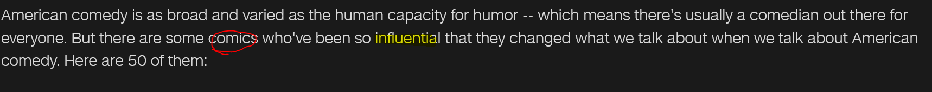

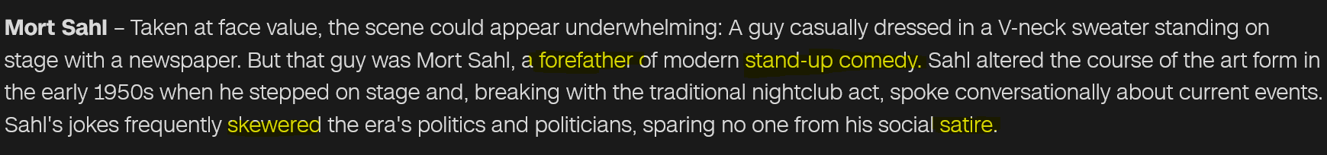

Skewer: two skewers of chicken: A **skewer** is a long pin made of wood or metal that is used to hold pieces of food together during cooking. 串肉扦; 烤肉叉

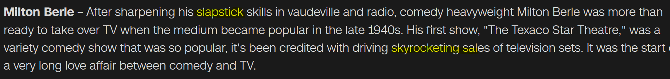

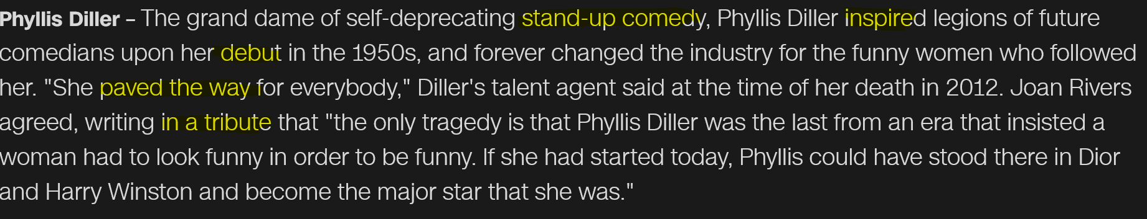

debut => debutant 初进社交界的人(名媛)

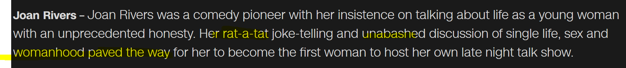



punchline **/ˈpʌntʃlaɪn/**  The **punchline** of a joke or funny story is its last sentence or phrase, which makes it funny. 笑话或警句令人发笑的最后一行

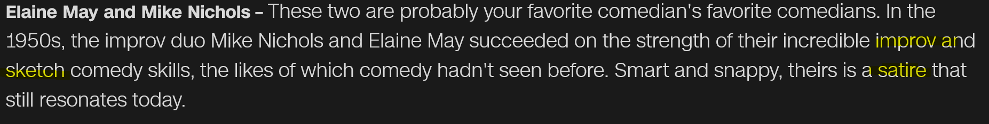

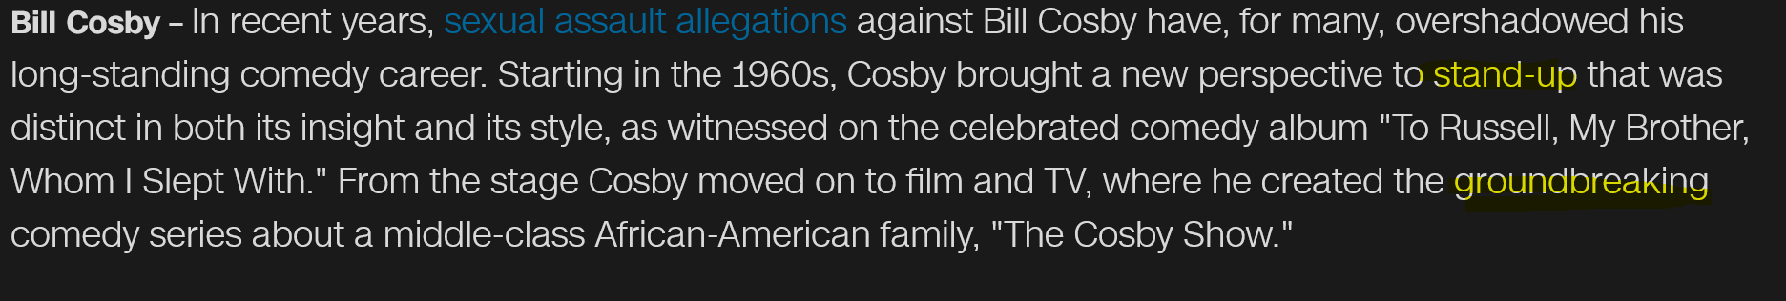

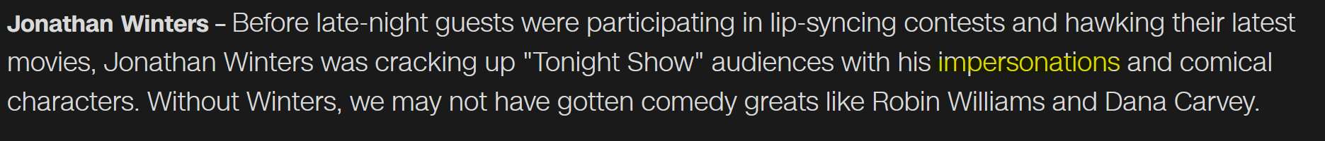

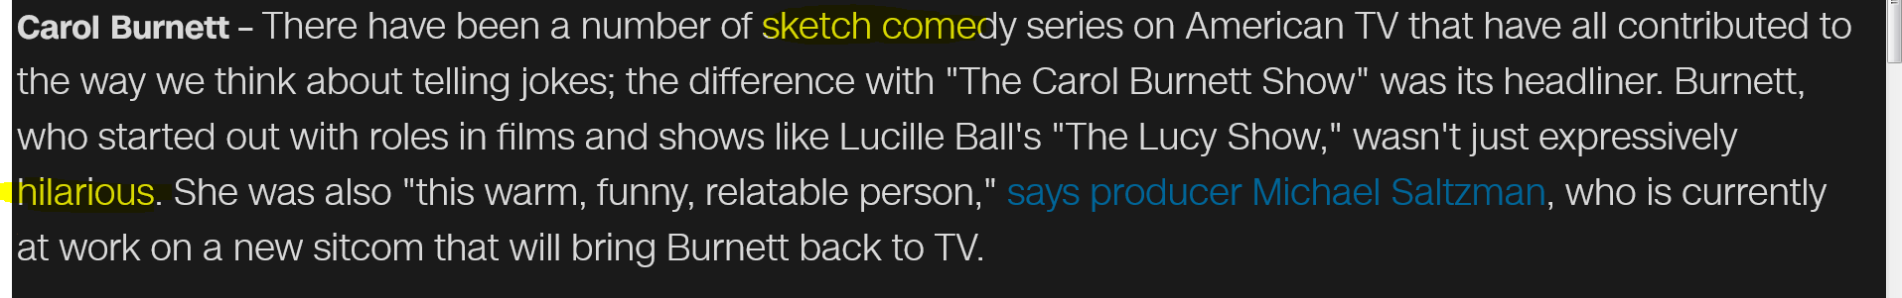

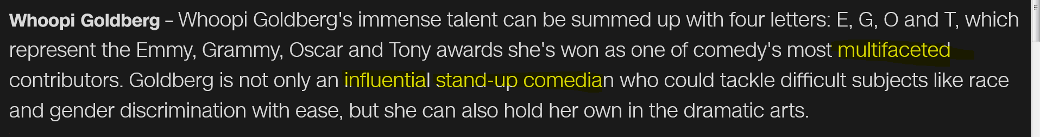

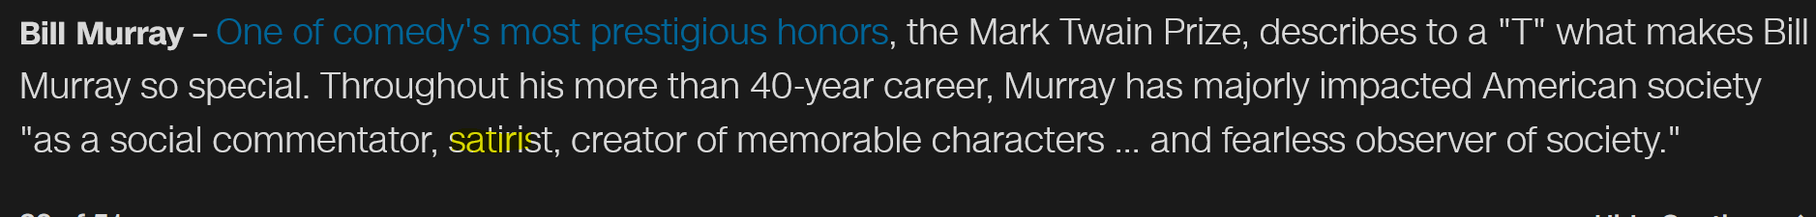

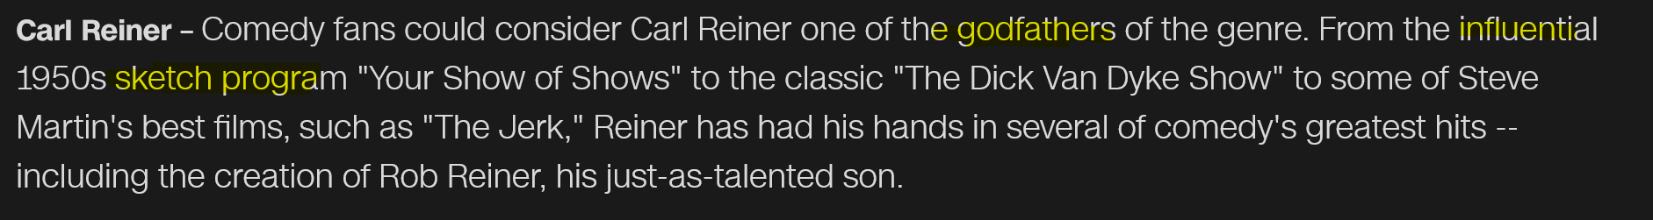

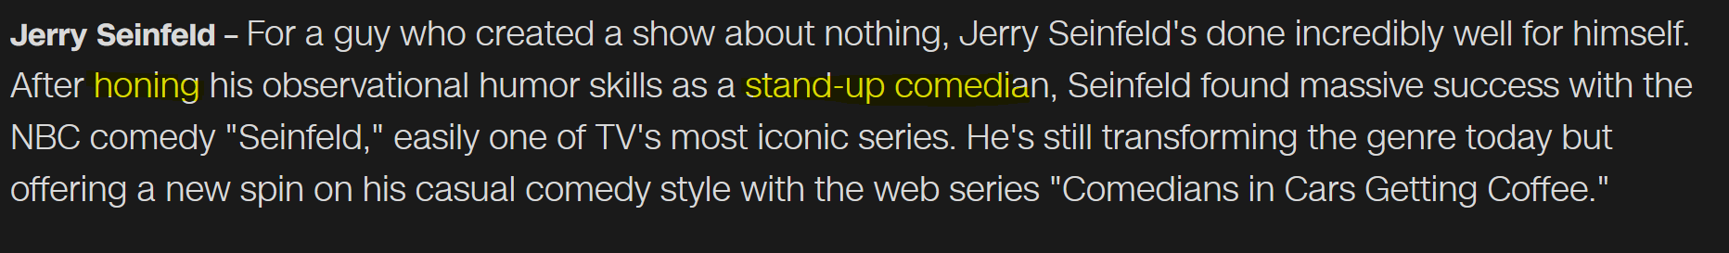

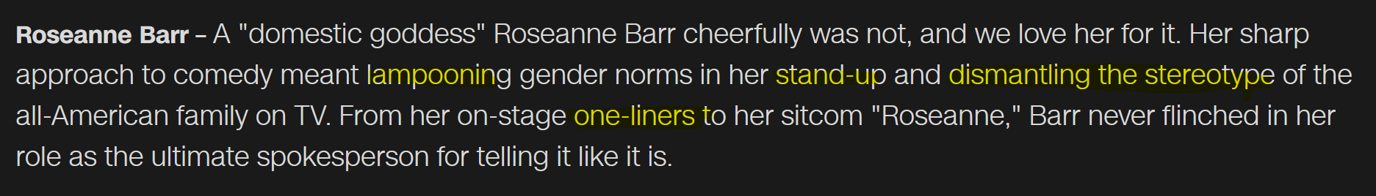

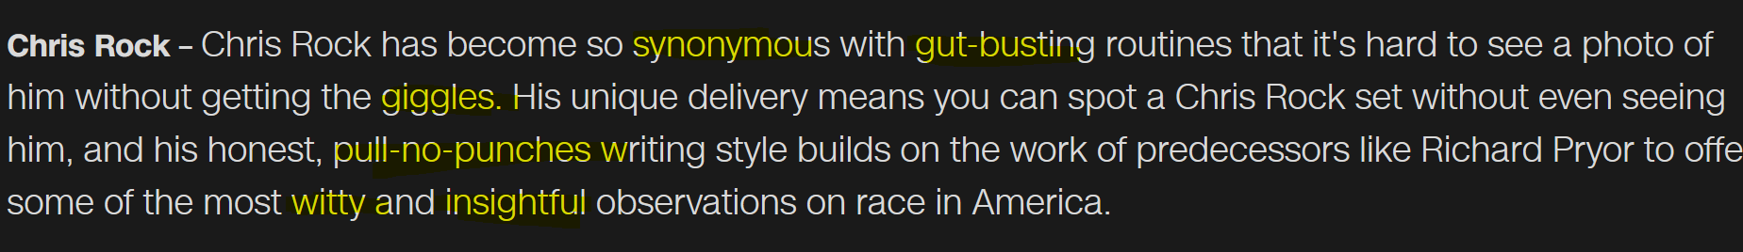

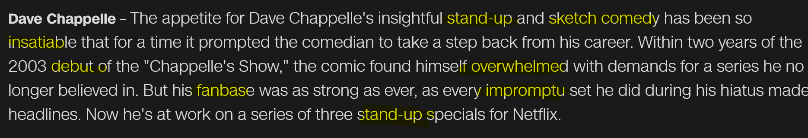

**Off-the-cuff = impromptu 即兴的（表演，台词） off-the-cuff, witty remarks即兴的诙谐的评论**

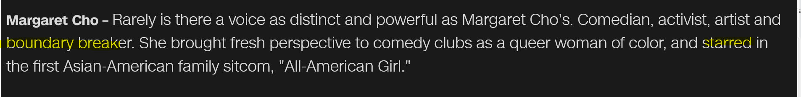

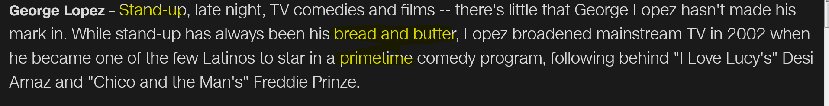

**Prime time; movie premiere**

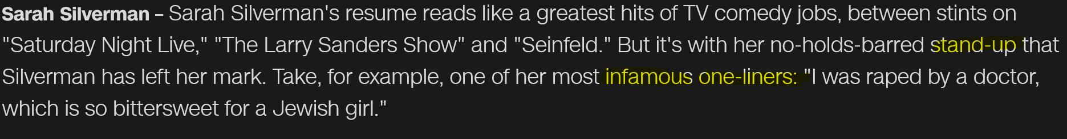

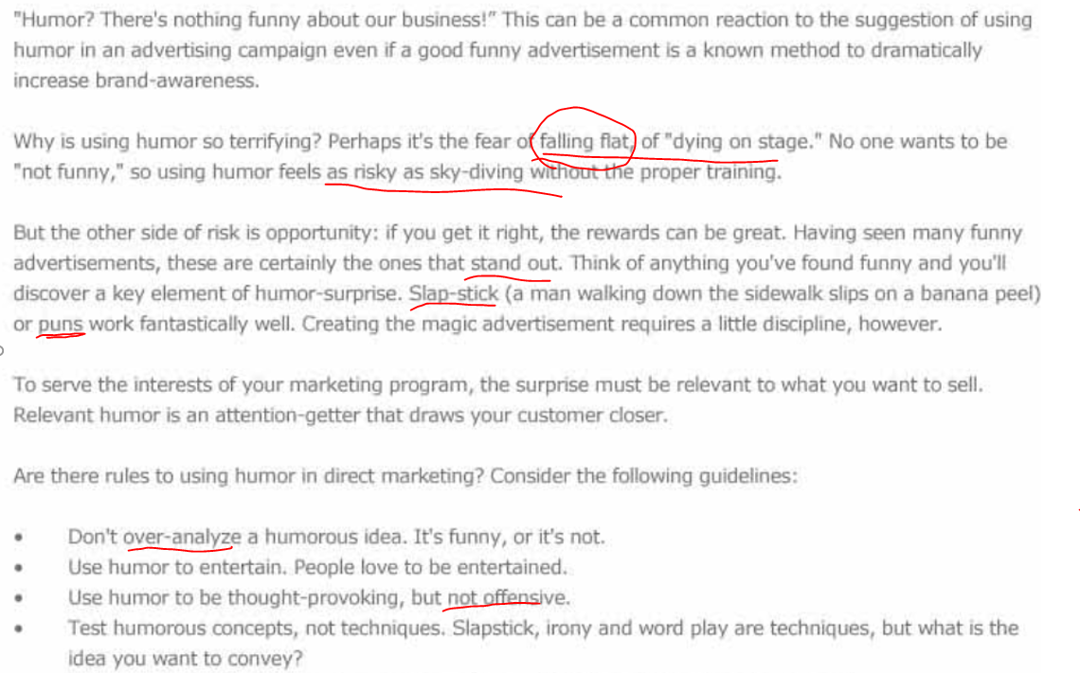

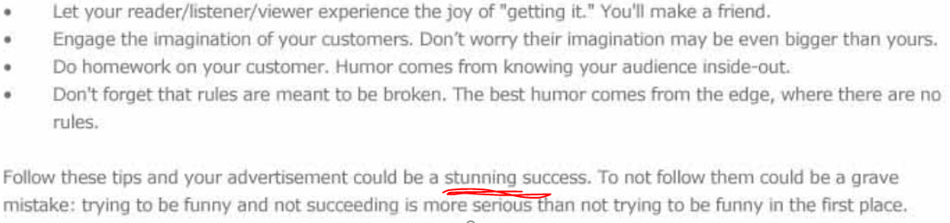

## **Jokes To Make Anyone Laugh**

Comedy servers many purposes. Comedy entertains us when we’re not feeling well. Tellings jokes to people helps bonding and brings you together as a society. Pushing the boundaries of comedy brings attention to social issues and injustices. Comedy and comedians has helped evolve the social world we live in. Humour is one of the most subjective of things that people experience. What may be funny to others may not be funny to you. It can be light, it can be **dark or black** (**dark humor/black humor).** Humour can be tasteful or it can push every boundary.

**10 funniest jokes**

There’s nothing less humorous than having to explain a joke. If these don’t work for you, just know these jokes are funny to others. The funniest jokes to most people in fact.

10 - A man goes to a chinese restaurant when a duck walks up to him. The duck says “Your eyes sparkle like the stars”. The man shouts at the waiter “Excuse me, I asked for an A-Romatic Duck for dinner” **. [ what does this joke mean? Ask EF teacher? ]**

9 - I went down to the corner store the other day. I bought four corners**. [ what does this joke mean? Ask EF teacher? ]**

7 - A woman enters an airplane and the stewardess tells the woman “Wow, that’s the ugliest baby I have ever seen”. In anger the woman goes to her seat and tells the passenger next to her that she was just insulted. The man beside her says “That’s an **outrage (over the top过分了),** go confront them about this! I’ll hold your monkey for you”

6 – (this’s hilarious) A snail rings a man’s doorbell. The man opens the door, picks up the snail and throws him away. **Four years later** the man hears the doorbell again, he opens the door to see the snail. The snail yells “What the hell was that about?” //the snail moves too slow😊

2 - There’s two fish in a tank, the first fish asks the other one, “How do you drive this?” **[ what does this joke mean? Ask EF teacher? ]**

1 - Three women are trapped on a desert island and they find a magic lamp. They agree that each of the women should get one wish. The first woman wishes to be back at home with her family. The genie ['dʒiː**nɪ**] 妖怪；鬼 grants her wish and sends her home. The second woman asks the genie to send her home to her family as well. The genie granted that wish as well. The third woman didn’t want to rush it so she waited a few days. Finally she told the genie “I’m lonely, I wish to have my friends back”.

## A boy died for a prank call

<http://edition.cnn.com/2017/04/10/us/boy-prank-death-trnd/index.html>

An 11-year-old boy who died last week of injuries suffered in a March suicide attempt will be laid to rest Tuesday. When Tysen Benz hanged himself March 14, he left no note. But his mother, says Benz was the victim of a **prank/hoax/mischief恶作剧** that drove him to take his own life. Benz killed himself after receiving a **prank** text messages that led him to believe a girl he considered his girlfriend had herself **committed suicide**.

Marquette County Prosecutor said on Monday that his office last week charged that 13-year-old girl with **malicious** use of telecommunication services and using a computer to commit a crime for sending false reports of her own death to Benz. Neither the prosecutor nor the Marquette Police Department would identify the 13-year-old, citing her age.

"The person sending the message purported to be a different person," Wiese said. The messages were "**Hoax- or prank-**like," he said, and they were sent directly to Benz. Wiese said it was impossible to tell if this was the cause of Benz's suicide, but called the connection logical.

Asked if there were others involved in the **prank**, Wiese said the investigation was ongoing, but "as of now, I have no reason to believe it was a group effort." Goss said Monday that she believes stronger **charges should have been filed against** the 13-year-old girl.

Benz was the middle child in a family of three boys. Goss described her son as "selfless to a fault." She said he was an avid athlete who played soccer, hockey and golf. Photos on social media showed Benz and his brothers in hockey uniforms. Goss said last week that Benz bought himself the phone he used to talk to the 13-year-old girl. "I would never buy my kids phones," she said. "I think that's ridiculous."

## Air India has introduced an innovative new cost-cutting measure: Meatless meals.

The struggling **budget airline** announced Monday that it has cut meat out of economy-class meals on domestic flights "to reduce wastage, reduce cost and improve catering service." Air India has been struggled to compete in the country's hugely competitive and fast-growing aviation market, needing a $4.5 billion government bailout in 2012 to keep flying. The government is now [looking to sell its stake](http://money.cnn.com/2017/06/29/news/india/air-india-privatization-sale/index.html?iid=EL) in the national carrier.

A representative for Air India said the meatless move, which started last week, would lead to "substantial savings" but declined to estimate how large the savings would be. Air India said it studied its meals data for several months and found that offerings with meat frequently went to waste.

India has the largest **vegetarian** population in the world. Over 391 million people -- or **roughly** 30% of Indians -- consider themselves to be **vegetarians**, according to data from Euromonitor. **Hindus** consider the cow to be sacred, and many keep to a strict **vegetarian** diet. Many restaurants and food producers cater directly to vegetarians, and meals are often divided into two categories: "veg" and "non-veg." However, **vegetarianism** has been on the decline, down about 8% over the past five years.

## Wells Fargo customers who had fake/**bogus['bəʊgəs]伪造的 accounts** created in their names are a step closer to some payback.

A federal judge granted preliminary approval over the weekend for Wells Fargo's [$142 million national class action settlement](http://money.cnn.com/2017/04/21/investing/wells-fargo-expands-customer-settlement/index.html?iid=EL)解决处理(的方法). The court ruled that the settlement, which covers [fake/ **bogus['bəʊgəs]伪造的accounts** back to 2002](http://money.cnn.com/2017/04/10/investing/wells-fargo-board-investigation-fake-accounts/index.html?iid=EL), "fair, reasonable and adequate."

Victims may still have to wait before they get paid. The bank and lawyers for the **plaintiffs/indictor/accuser** plan to reach out to customers in the next three months, but the **settlement解决处理(的方法).** may not be final until early 2018.

Still, Wells Fargo CEO called the court ruling a "major milestone in our efforts to make things right for our customers." Wells Fargo admitted last September that 2 million potentially unauthorized checking and credit card accounts were **bogus['bəʊgəs]伪造的** between 2011 and 2015. The bank blamed [unrealistic sales goals](http://money.cnn.com/2017/04/21/investing/wells-fargo-expands-customer-settlement/money.cnn.com/2017/01/06/investing/wells-fargo-replace-sales-goals-fake-accounts/?iid=EL). The outrage forced the **ouster** of longtime CEO John and the restructuring of Wells Fargo's sales targets, and it spawned [federal and local investigations.](http://money.cnn.com/2017/07/10/investing/wells-fargo-fake-account-settlement/money.cnn.com/2017/03/31/investing/wells-fargo-investigations-fake-account-scandal/?iid=EL)

Derek Loeser, a partner at the **law firm** and lead **attorney** for the **plaintiffs/ indictor/accuser**, hailed this feature of the settlement as "groundbreaking" and "first-of-its kind." The **settlement解决处理(的方法)** is an important step toward "**holding Wells Fargo accountable for** its abuse of customers' trust,".

The $142 million will first go to lawyer fees and administrative costs. Then Wells Fargo customers will be paid for **out-of-pocket字掏腰包的** losses, such as fees from **fake/bogus accounts**. What's left will be split among all customers, based on how many and what kind of accounts they say were opened. Wells Fargo has agreed to put more money in the settlement fund if less than $25 million is left for wronged customers after paying the lawyers, expenses and **out-of-pocket costs/expenses.**

## Toxic mortgages不良的抵押贷款

<http://money.cnn.com/2017/07/12/investing/rbs-settlement-toxic-mortgages/index.html>

The Royal Bank of Scotland has agreed to pay $5.5 billion to settle claims that it sold **toxic mortgages** (risky loans**不良的抵押贷款)** prior to the financial crisis. RBS has already **set aside** most of the funds needed to resolve allegations made by the Federal Housing Finance Agency that it packaged and sold **risky loans (that is toxic mortgages)** worth over $30 billion to U.S. mortgage giants Fannie Mae and Freddie Mac.

This **settlement** (解决方法) is a **stark** reminder of what happened to this bank before the financial crisis, and **the heavy price that it’is paid for** (付出的高额代价) its pursuit of global ambitions. **// a stark contrast to sth　明显的对比**

Gains made by RBS ([RBS](http://money.cnn.com/quote/quote.html?symb=RBS&source=story_quote_link)) shares on Wednesday were wiped out following the announcement. The bank still faces a separate investigation by U.S. **Department of Justice** over the sale of **risky mortgages, that is “toxic mortgage不良的抵押贷款**”.

RBS, formerly the largest bank in the world, was **bailed out** by the British government in 2008. The government still owns more than 70% of the firm, which has reported nine consecutive years of losses totaling £58 billion ($74.7 billion). **// be released on bail 保释 //n) bailout: financial bailout =v) bail sb out(常通过提供资金) 帮助…摆脱困境**

"Our policy remains to return the bank to private hands as soon as we can achieve fair value for the shares, recognizing that fair value could well be below what the previous Government paid for them," he told parliament in April. The bank failed **stress tests** performed by the Bank of England in November.